FIELD REPORT
Introduction
- Place: ATURA HC III
- Location: Atura, Oyam district
- Date of visit: 24th August 2026
1. General observations
According to the facility representative, the UgIFT-supported equipment has strengthened the facility’s capacity to provide diagnostic services, contributing to improved service delivery within the community.
However, the facility faces significant space constraints, which affect the appropriate placement and utilization of some of the equipment. The facility indicated that some items may be better utilized if redistributed to other health centers with adequate space and capacity to use them effectively.
Special notes
- Asset verification and documentation
The asset verification exercise was conducted with support from a facility representative, as the facility in-charge was not present at the time of the visit. The team used the facility’s inventory book as the main facility-level reference, supplemented by the available delivery notes, to guide the physical verification of the UgIFT-supported assets.
However, the verification was subject to some limitations. The UGIFT-supported assets were not engraved or marked with project-specific identification, making it difficult to independently distinguish them from other similar assets at the facility. This also presents an accountability and security concern, as unmarked assets may be more difficult to trace and could be at greater risk of loss or theft.
The facility maintains an inventory book to track the movement and status of assets, including updates when items are taken from the store or disposed of. However, the storekeeper was not available during the visit, and the team was therefore unable to access and physically verify some of the items reportedly kept in the store.
Overall, the absence of project-specific asset identification, limited access to some stored items, and reliance on the inventory book and delivery notes affected the extent to which all UgIFT-supported assets could be independently verified.
Assets are still in store, with many of them not being used and none of the assets are engraved.

The table below illustrates some physical status of the verified assets with photographic evidence.
Table XXX: Physical verification photos
ATURA HC III SIGN POST | 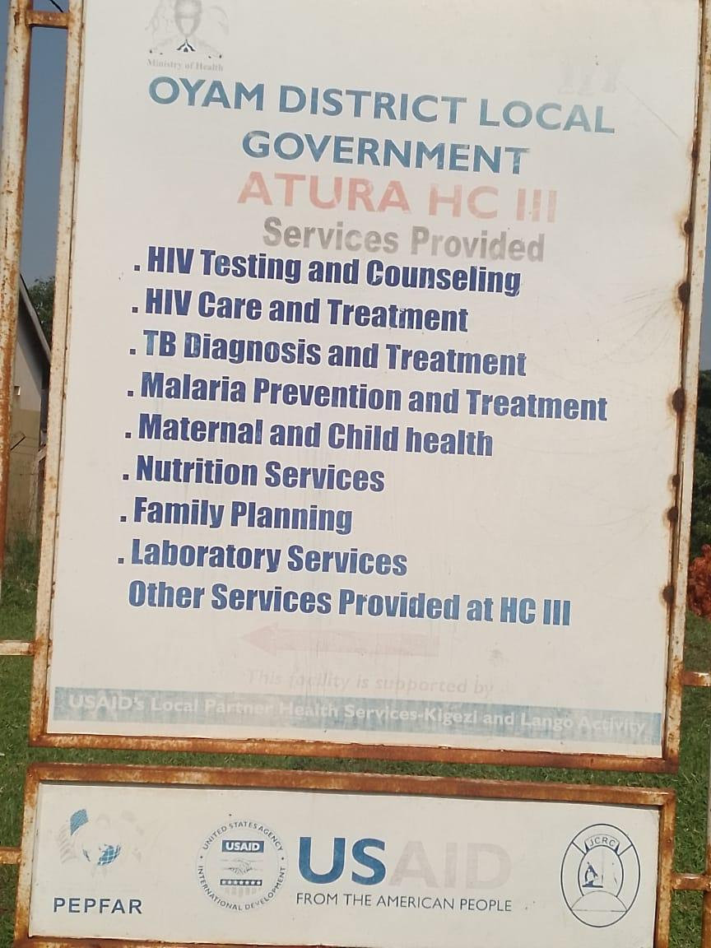
SAMPLE OF ITEMS IN STORE | 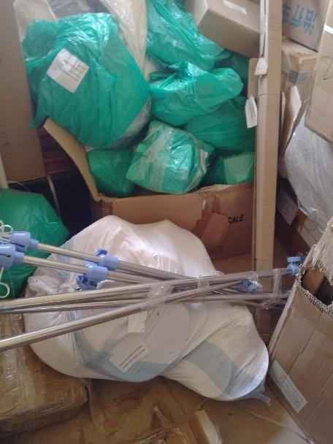
SAMPLE OF ASSETS IN STORE | 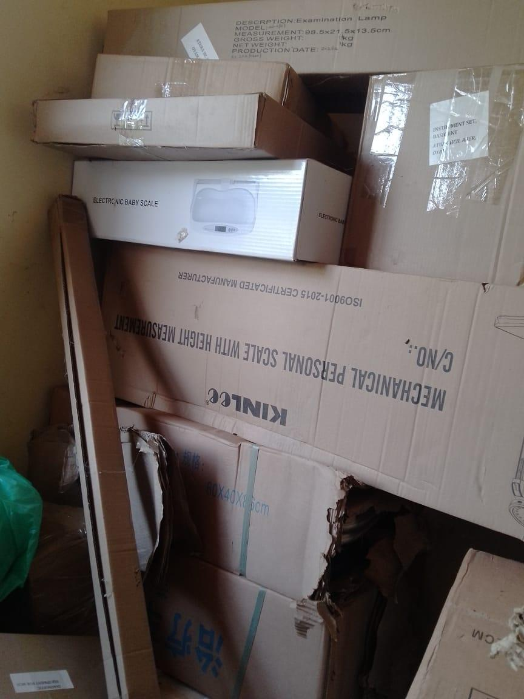
SAMPLE OF ASSETS IN STORE | 